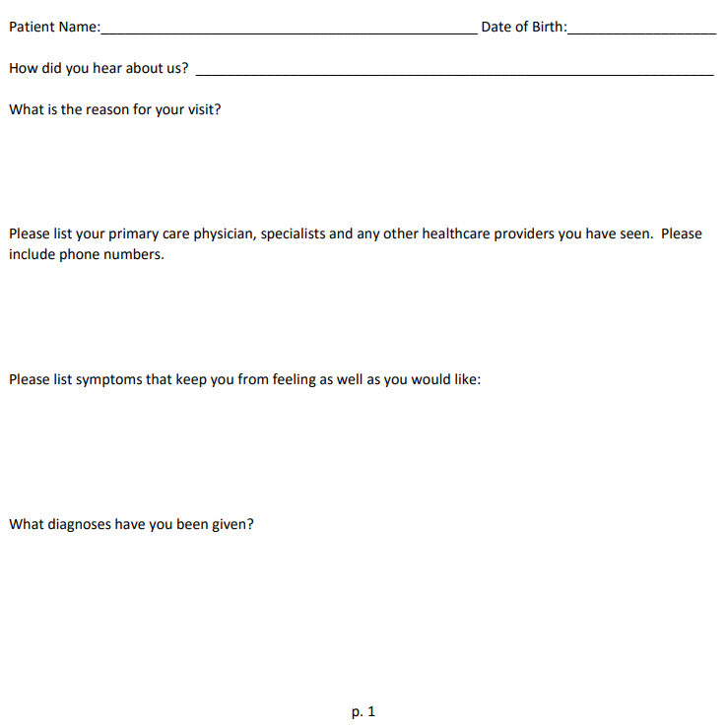

Have you ever been hospitalized?
If yes, when and why?

Are you taking any pharmaceutical or homeopathic medications and or nutritional supplements? Please list all:
Include dosing and how often you are taking them. (Ex: 1 time daily)

Please list all allergies including food, medication and environment.

Please describe your food and liquid intake in detail (eating habits):

P. 2
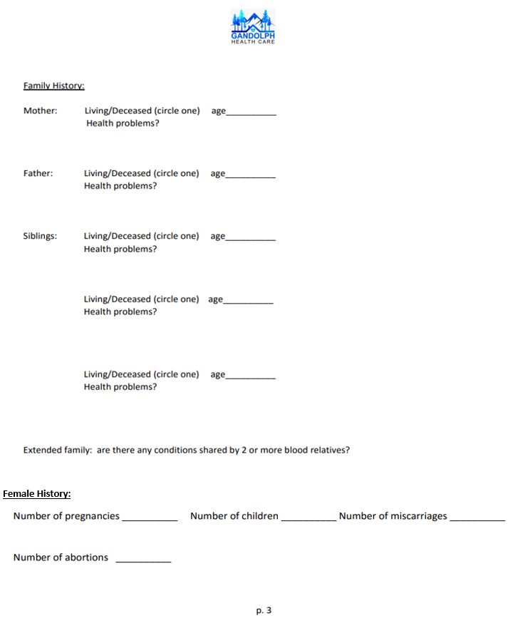

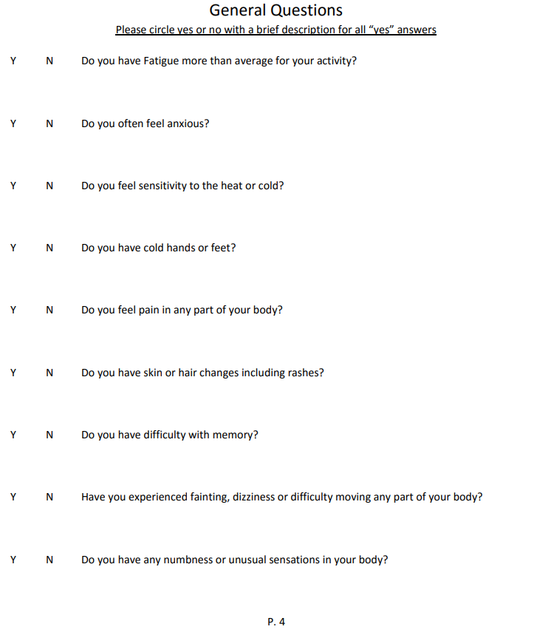

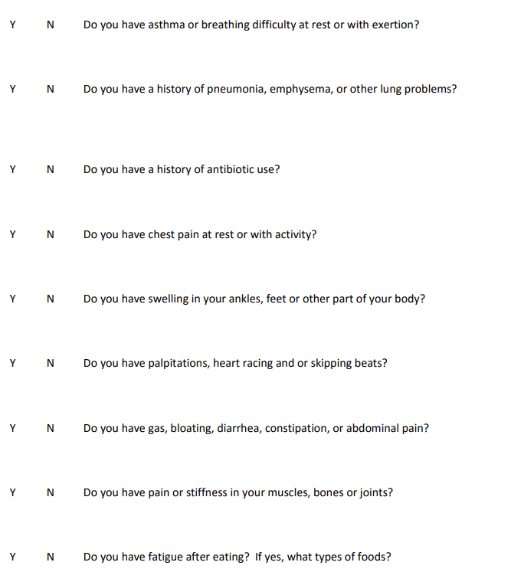

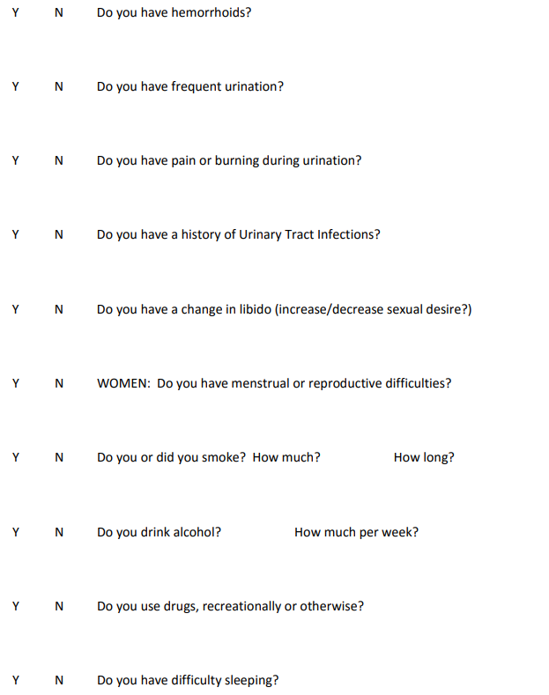

Last Dental Exam?
Last Eye Exam?
Last mammogram if applicable?
Last Colonoscopy?

Please list any individuals you authorize us to discuss your medical information:

P.7

